DE Results Summary

1. G1.D.S-G1.D.NS DE analysis (drought +Si Vs Drought)

|  | **Number** |
| --- | --- |
| down-regulated DEG | 3469 |
| Non DEG | 14670 |
| up-regulated DEG | 3695 |

Estimated Dispersion

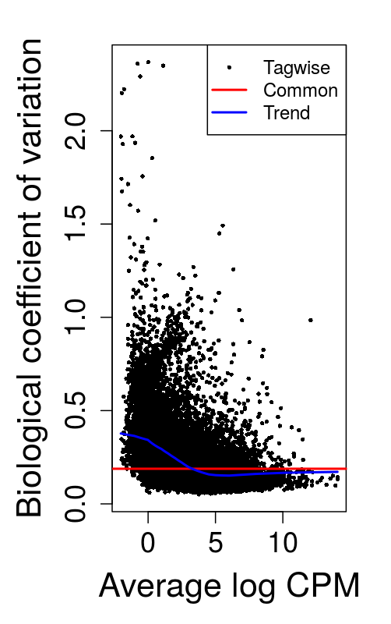

olcano Exploration

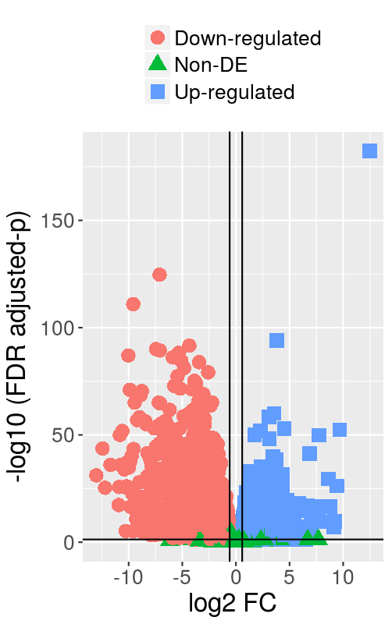

### DE Results Summary

#### G1.ND.NS-G1.D.NS DE analysis control vs drought

|  | **Number** |
| --- | --- |
| down-regulated DEG | 3190 |
| Non DEG | 15588 |
| up-regulated DEG | 3056 |

### Estimated Dispersion



### Volcano Exploration

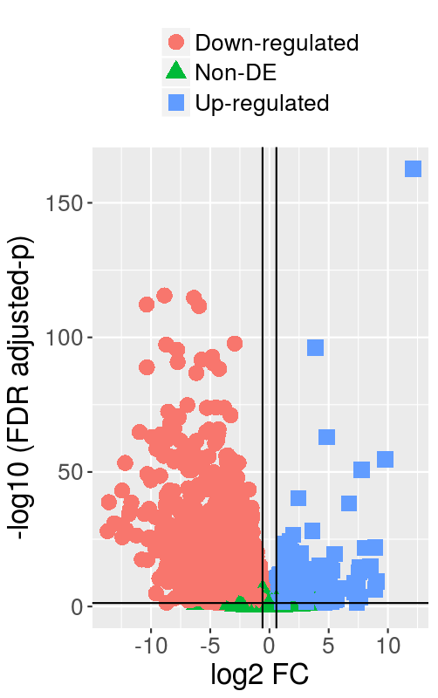

### DE Results Summary

#### G1.ND.S-G1.D.NS DE analysis

|  | **Number** |
| --- | --- |
| down-regulated DEG | 3101 |
| Non DEG | 15853 |
| up-regulated DEG | 2880 |

### Estimated Dispersion



### olcano Exploration

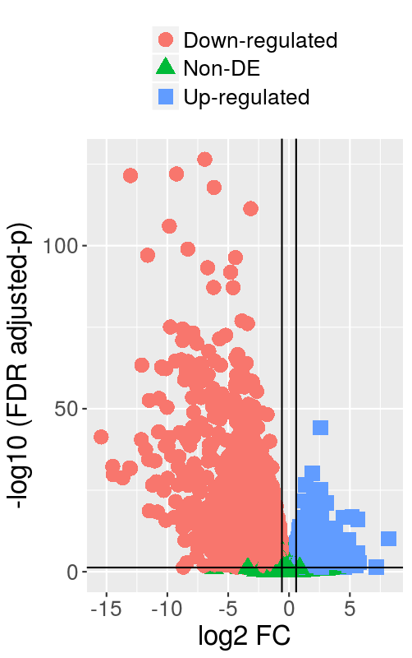

### DE Results Summary

#### G1.ND.NS-G1.D.S DE analysis

|  | **Number** |
| --- | --- |
| down-regulated DEG | 2619 |
| Non DEG | 16800 |
| up-regulated DEG | 2415 |

### Estimated Dispersion



### olcano Exploration

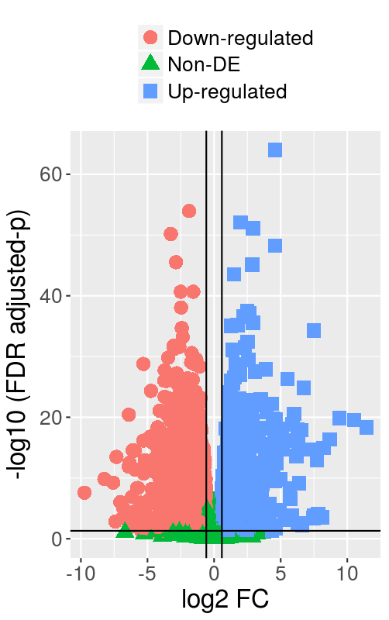

#### G1.ND.S-G1.D.S DE analysis

|  | **Number** |
| --- | --- |
| down-regulated DEG | 2700 |
| Non DEG | 16784 |
| up-regulated DEG | 2350 |

### Estimated Dispersion



### Volcano Exploration

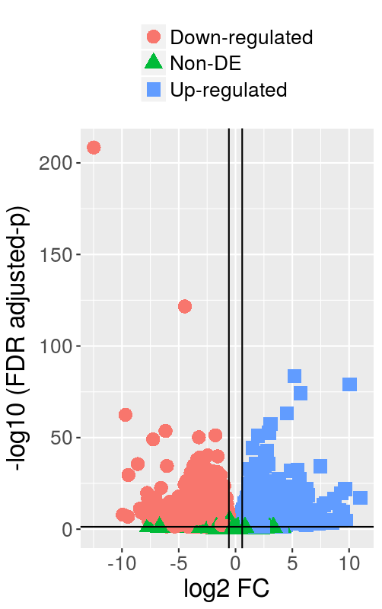

#### G1.ND.S-G1.ND.NS DE analysis silicon and control

|  | **Number** |
| --- | --- |
| down-regulated DEG | 75 |
| Non DEG | 21707 |
| up-regulated DEG | 52 |

### Estimated Dispersion



### Volcano Exploration

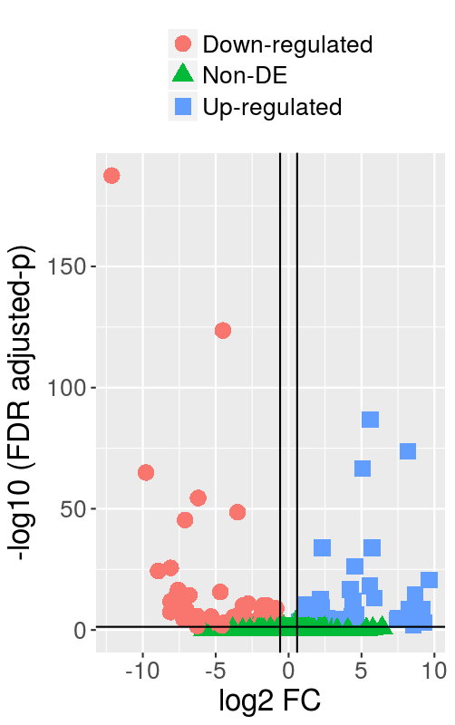

#### G2.D.S-G2.D.NS DE analysis

|  | **Number** |
| --- | --- |
| down-regulated DEG | 2499 |
| Non DEG | 16258 |
| up-regulated DEG | 3077 |

### Estimated Dispersion



### Volcano Exploration

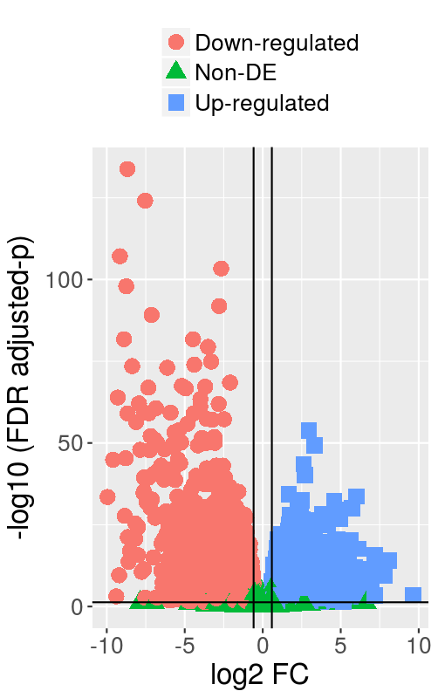

#### G2.ND.NS-G2.D.NS DE analysis control vs drought

|  | **Number** |
| --- | --- |
| down-regulated DEG | 2950 |
| Non DEG | 15151 |
| up-regulated DEG | 3733 |

### Estimated Dispersion



### Volcano Exploration

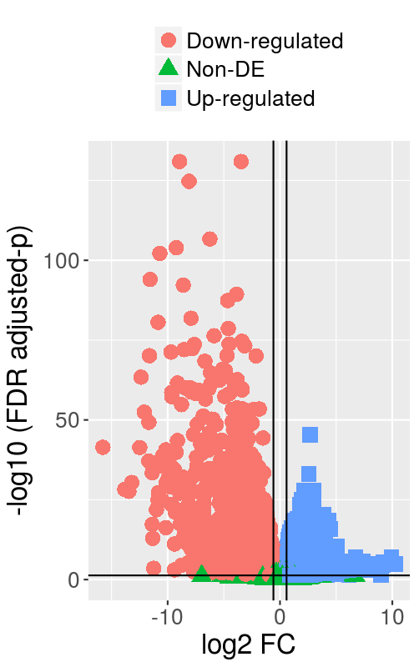

#### G2.ND.S-G2.D.NS DE analysis

|  | **Number** |
| --- | --- |
| down-regulated DEG | 3536 |
| Non DEG | 15109 |
| up-regulated DEG | 3189 |

### stimated Dispersion



### Volcano Exploration

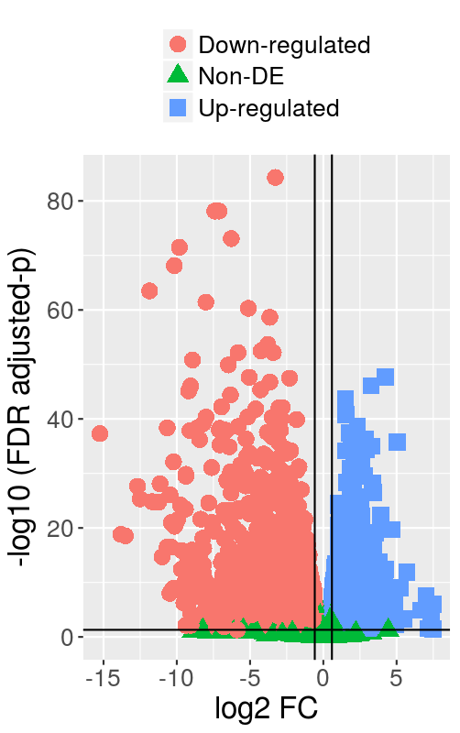

#### G2.ND.NS-G2.D.S DE analysis

|  | **Number** |
| --- | --- |
| down-regulated DEG | 2277 |
| Non DEG | 17391 |
| up-regulated DEG | 2166 |

### Estimated Dispersion



### olcano Exploration

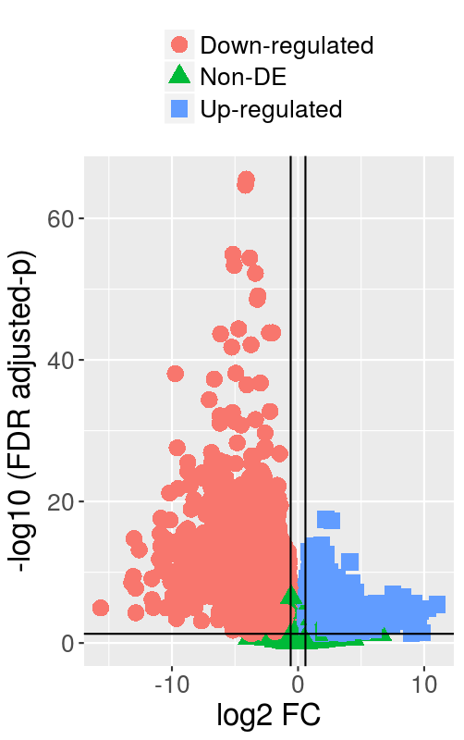

#### G2.ND.S-G2.D.S DE analysis

|  | **Number** |
| --- | --- |
| down-regulated DEG | 2960 |
| Non DEG | 16729 |
| up-regulated DEG | 2145 |

### Estimated Dispersion



### Volcano Exploration

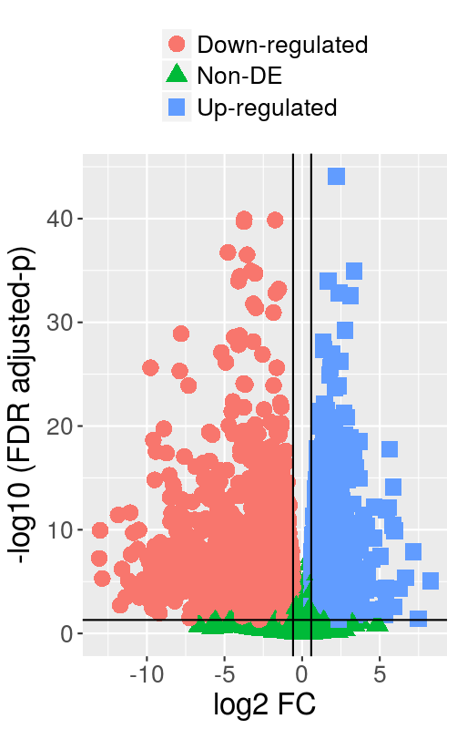

#### G2.ND.S-G2.ND.NS DE analysis contol vs si

|  | **Number** |
| --- | --- |
| down-regulated DEG | 2793 |
| Non DEG | 17053 |
| up-regulated DEG | 1988 |

### Estimated Dispersion



### olcano Exploration

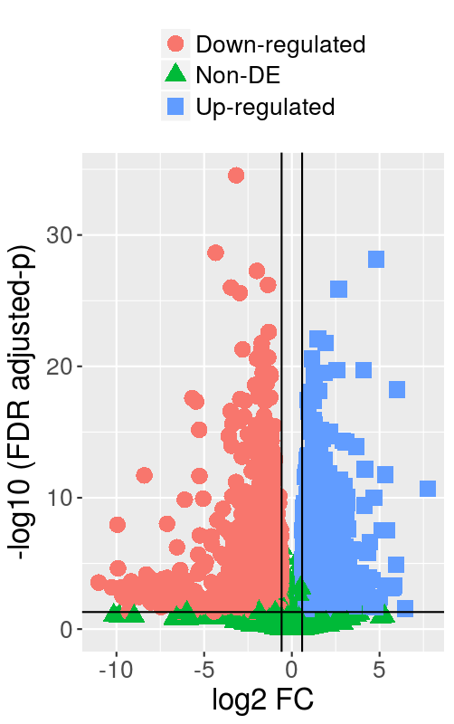

#### G2.D.NS-G1.D.NS DE analysis

|  | **Number** |
| --- | --- |
| down-regulated DEG | 1845 |
| Non DEG | 17834 |
| up-regulated DEG | 2155 |

### stimated Dispersion



### olcano Exploration

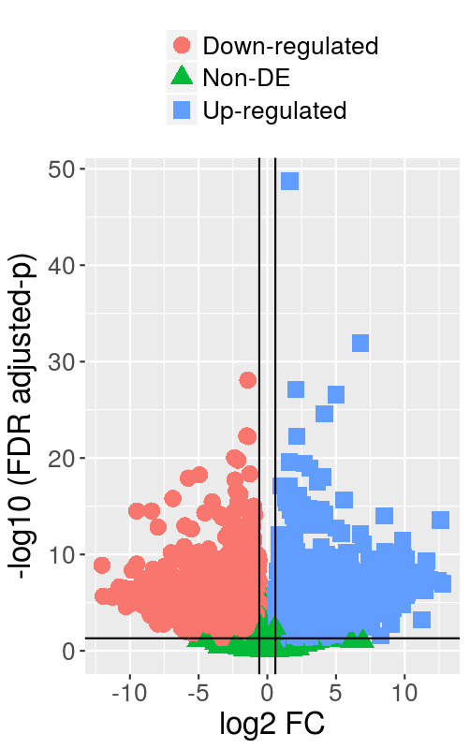

#### G2.D.S-G1.D.S DE analysis

|  | **Number** |
| --- | --- |
| down-regulated DEG | 3811 |
| Non DEG | 13437 |
| up-regulated DEG | 4586 |

### Estimated Dispersion



### Volcano Exploration

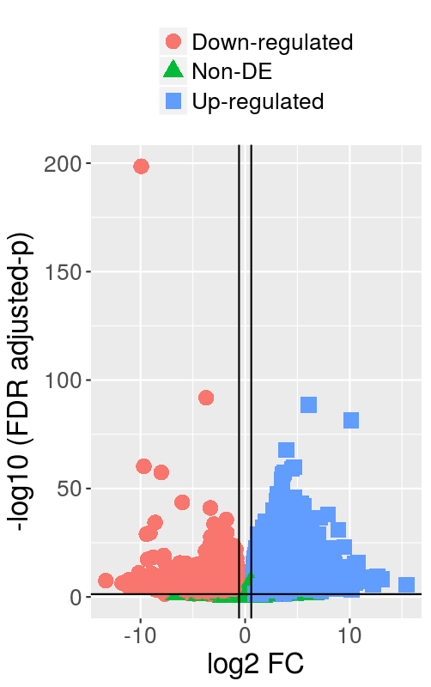

#### G2.ND.NS-G1.ND.NS DE analysis

|  | **Number** |
| --- | --- |
| down-regulated DEG | 837 |
| Non DEG | 18979 |
| up-regulated DEG | 2018 |

### Estimated Dispersion



### Volcano Exploration

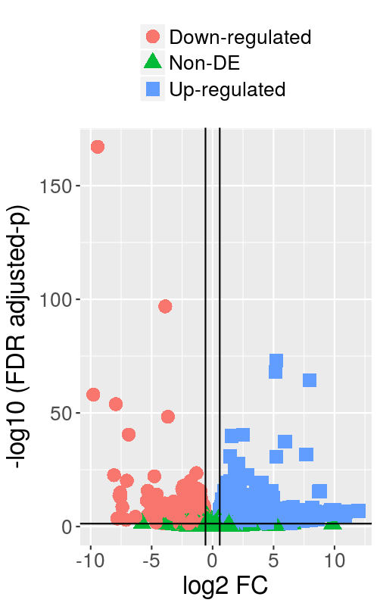

#### G2.ND.S-G1.ND.S DE analysis

|  | **Number** |
| --- | --- |
| down-regulated DEG | 3887 |
| Non DEG | 13750 |
| up-regulated DEG | 4197 |

### Estimated Dispersion



### Volcano Exploration

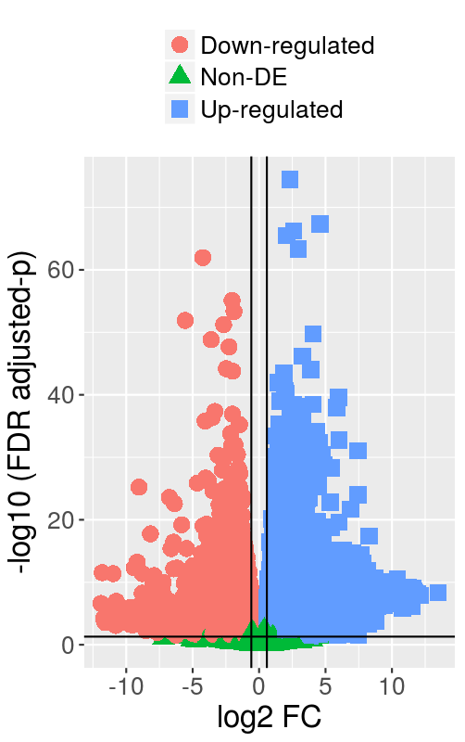

GO TO STEP 4: Methods Comparison